**Project Scope**

Project name: Assignment 2 – Intruder Counter Project

Team members: Kin Seng Chan, Chuen Wern Wai

Team number: 60

Project description

For this project, it is created to able to calculate how many intruders a IoT motion sensor can detect. To consider that there is an intrusion, the sequence of the motions has to be “Long Short Long Long”. The hardware components that are needed in this project are, an Arduino board, a motion sensor, a LED. The Arduino board is used to able to perform functions that the programmer writes, such as to on or off an LED.

Besides that, in order to make the project work, connect all the hardware components together. Follow the image below to connect all the hardware component.

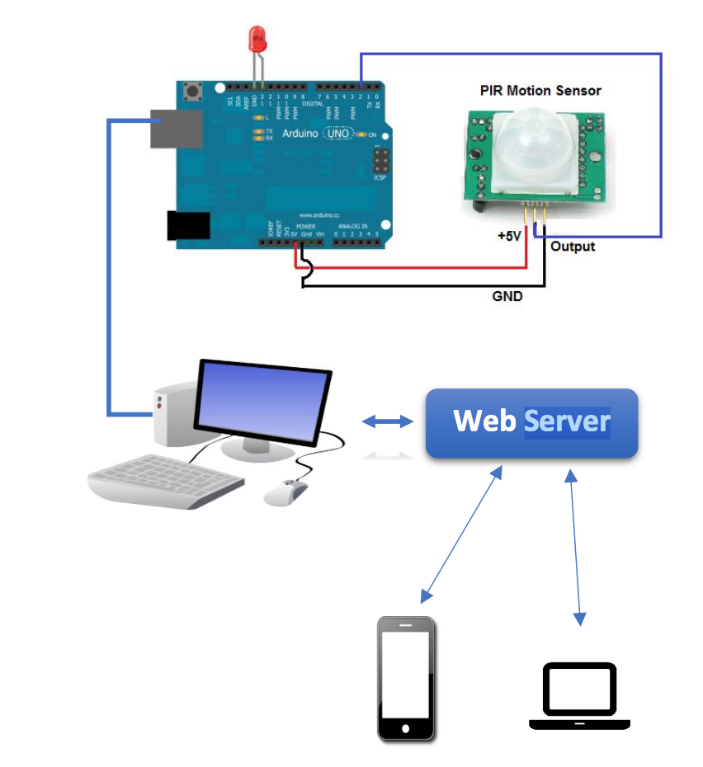

Johnny-Five is used in this project which its purpose is to connect the board to able to perform tasks.

The intruder counter will increment by 1 when there is a sequence of motion “Long Short Long Long”. If the motion sensor has detected a motion that is more than 5 seconds, the motion will consider as a “Long” motion. If the motion sensor has detected a motion that is less than 5 seconds, the motion will consider as a “Short” motion. If the sequence is not “Long Short Long Long”, it will not calculate as an intruder.

There is a client side and a server side for this project. The client side, a web page, is used by the users if they want to use the hardware component. The server side contain codes, Node.js, that trigger hardware components to perform functions if users make some actions. To able to connect the client side and the server side, Google Firebase is used as a communication platform to transfer data from client side to server side or vice versa. With Google Firebase, if users accidentally have closed the web page, the data in this project will not be lost as they have already been stored in the Google Firebase.

For the client side, a web page, there is a section which let users to switch the LED on and off. Users will just need to click the ON the button below the LED Controller to turn on the LED and click the OFF button to turn off the LED. Besides that, buttons below Motion Controller are used to switch the motion sensor on and off. Once users click on the ON button, the motion sensor will start to detect if there is a motion in the surrounding. Motion more than 5 seconds is a long motion. Therefore, the long motion counter will increase by 1 and display below the Long Motion label. Same goes to motion below 5 seconds, short motion. Below the Motion Detected, it will display the total number of motion detected by the motion sensor. Intruder Counter is added below to display total number of intrusion. If the users click the Off button, it will stop the motion sensor and the value of Motion Detected, Long Motion, Short Motion and Intruder Counter will not be changed. Last but not least, a Reset button is used to rest all the motion values so that users can restart the motion sensor to detect the surrounding motions.